Introduction to metasploit framework:
The source code is available on the github ,Open source
Penetration testing /Exploitation framework
Penetration tester and security researchers

Automate every stage of the penetration testing life cycle.

Develop and test exploits.

Design to be modular, easily add new functionality.

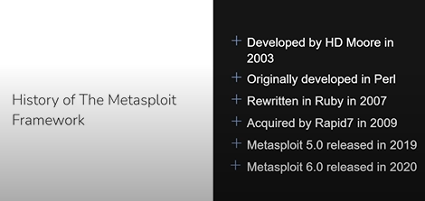

We are using the 6.0 right now.

Metasploit Editions:
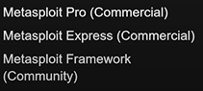

Essential terminology:
Interface: interact with measploit such as msfconsole ,CLI MSFcli etc.

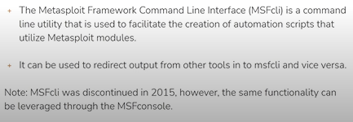

Module: auxiliary , exploit
Vunerability
Exploit
Payload
Listener

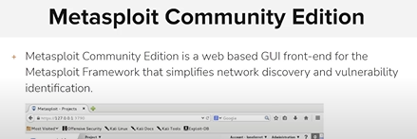
We-based == network discovery and vulnerability identification.

Msfconsole (cli) == Armitage (gui)

